Ideation Phase

Define the Problem Statements

|  |  |
| --- | --- |
| Team ID | PNT2022TMID17537 |
| Project Name | Project - **A Gesture-based Tool for Sterile Browsing of Radiology Images** |

# Problem Statement:

A major challenge involved is to provide doctors with efficient,initiative,accurate and safe means of interaction without affecting the quality of their work.However,the use of computer key-boards and mouse by doctors and nurses in intensive care units is a common method for spreading infections.we suggest the use of hand gesture in medical field as an alternative to existing interface technique offering the major advantages of sterility.In this project, In this project we have used Convolutional Neural Network to first train the model on the images of different hand gestures, like showing numbers with fingers as 0,1,2,3,4,5. Then we made a web portal using Flask where user can input any image on which he wants to perform the operations. After uploading the image, our portal uses the integrated webcam to capture the video frame using OpenCV. The gesture captured in the video frame is compared with the Pre-trained model and the gesture is identified. If the prediction is 0 - then images is converted into rectangle, 1 - image is Resized into (200,200), 2 - image is rotated by -45॰, 3 - image is blurred , 4 - image is Resized into (400,400) , 5 - image is converted into grayscale, but in real time we use of doctor-computer interaction devices in the operation room (OR) requires new modalities that support medical imaging manipulation while allowing doctors' hands to remain sterile, supporting their focus of attention, and providing fast response times. This paper presents "Gestix," a vision-based hand gesture capture and recognition system that interprets in real-time the user's gestures for navigation and manipulation of images in an electronic medical record (EMR) database. Navigation and other gestures are translated to commands based on their temporal trajectories, through video capture. "Gestix" was tested during a brain biopsy procedure. In the in vivo experiment, this interface prevented the surgeon's focus shift and change of location while achieving a rapid intuitive reaction and easy interaction. Data from two usability tests provide insights and implications regarding human-computer interaction based on nonverbal conversational modalities.

# Example:

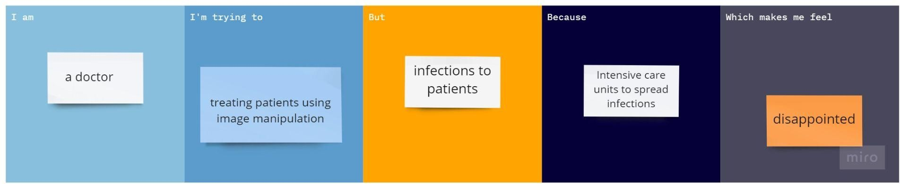

|  |  |  |  |  |  |
| --- | --- | --- | --- | --- | --- |
| **Problem**  **Statement (PS)** | **I am**  **(Customer)** | **I’m trying to** | **But** | **Because** | **Which makes me feel** |
| PS-1 | a doctor | treating patients  using image manipulation | infections to  patients | Intensive  care units to spread  infections | disappointed |
| PS-2 |  |  |  |  |  |